**SIGNALS AND SYSTEMS - ECE210**



**SUBMITTED TO: -**

**prof. ASHOK RANADE**

**submitted by: -**

**KARAN SHAH (AU1940292)**

**DIGVIJAYSINH GOHIL (AU1940199)**

**PANKIL SHETH (AU1940280)**

**MEET JHAVERI (AU1940284)**

**Image Processing using FFT**

**Synopsis:**

Converting input image into its Fourier transform image and then reconstructing it into the original image. Fourier transform gives us some information about the original image. By the spectrum of image on x and y axes with some brighter and darker regions we can represent original image. Its application is that if the low-quality image is given as input its quality can be improved by making some changes in the Fourier co-efficient.

**Problem Statement:**

When the image is transmitted from the one end to another the information of the image gets attenuated due to the channel noise, other information signals that are being transmitted with it and also due to natural calamities or environment. So when the image is received it is not proper. So in order to get the image enhanced we are using Fourier transform. To improve the image-quality.

**Methodology:**

**Programming Language to be used:** MATLAB Script.

**Description of user interface:** User has to provide the complete path of the image and as a result Fourier transform of the image will be we done.

**Processing Techniques:**

* Matrix Laboratory for coding.
* Using different inbuilt MATLAB functions :
* imread: For reading image.
* imshow : For displaying image.
* rgb2gray: For converting coloured image to gray scale image.
* fft: For fourier transform of image.
* ifft: For inverse fourier transform of image. ( For reconstructing Image)
* fftshift: For shifting low frequency component to center of spectrum.
* ifftshift: For the reconstruction of image.
* Here Fourier transform technique is used.
* Fourier transform is a mathematical technique that transforms a function of time to the function of frequency.
* Fourier transform decomposes an image into its sine and cosine components. From this we get Fourier co-efficient.
* We can approximate original image frequency plot by getting Fourier co-efficient.
* Output of this transformation represents the image in frequency domain.
* Fourier transform gives us some information about the original image.
* In Fourier domain image, each point represents particular frequency.
* By the spectrum of image on x and y axes with some brighter and darker regions we can represent original image.
* Then we try to enhance image by applying the logarithmic scale and apply Inverse Fourier Transform and reconstruct the image.
* Converting Gray Scale Image to colouring by using the function gray2rgb. It not a inbuilt MATLAB function.
* Lower peak: Black or darker region.
* Higher peak: White or brighter region.
* In darker there are high frequencies as they contain all the frequencies and in brighter region there are low frequencies.

**Flow Chart:**

STARTTTTTT^T

INPUT IMAGE

GIVE THE EXACT PATH OF THE IMAGE

CONVERTING TO GRAY SCALE IMAGE

APPLYING FOURIER TRANSFORM

LOGARITHMIC IMAGE

APPLYING INVERSE FOURIER TRANSFORM

STOP

**MATLAB Code:**

clc;

clear all;

close all;

% Reading an image

X=imread('peppers.png');

figure(1);

imshow(X);

title('Original Image');

% Gray Scale Image

gray_img=rgb2gray(X);

figure(2);

imshow(gray_img);

title('Gray Scale Image');

% Applying fourier transform on gray scale image

F=fft2(gray_img);

figure(3);

imshow(F,[]);%minimun value as black and maximum value as white

title('Fourier Transform of Image');

% Shifting fourier domain towards DC level

F1=fftshift(F);

figure(4);

imshow(F1,[]);

title('Centered Fourier Transform of Image');

% Applying Logarithmic Scale on Image

log_image=log(1+F1);

figure(5);

imshow(log_image,[]);

title('Log of Fourier Transformed Image');

% Inverse Fourier Transform

F2=ifftshift(F1);

F3=ifft2(F2);

figure(6);

imshow(F3,[]);

title('Reconstructed Image');

% Converting gray scale image into colored image

R=gray2rgb(F3,X);

figure(7);

imshow(R);

title('Converted Gray Scale Image to Coloured');

**Results & Analysis:**

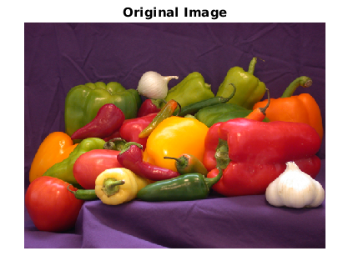

**Analysis 1:** Loading the Image.

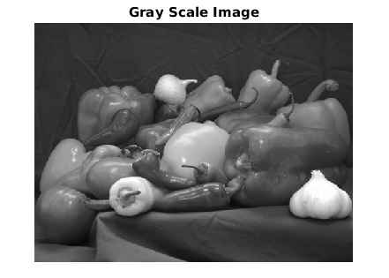

**Analysis 2:** Coloured Image is converted into gray scale image.

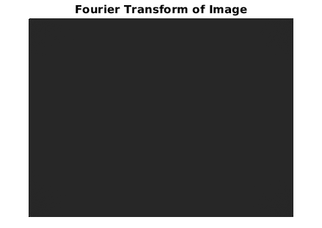

**Analysis 3:**  It does not give any information of original image.

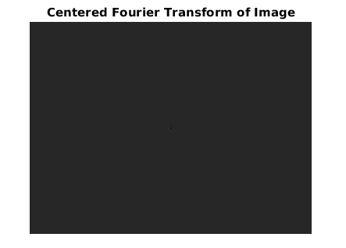

**Zoomed Image:**

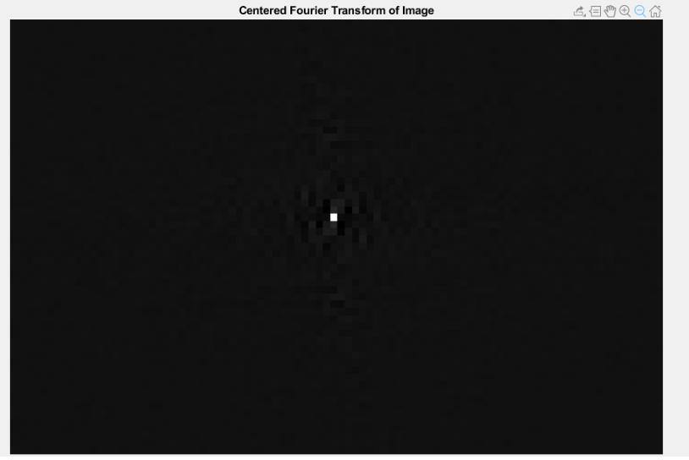

**Analysis 4:**  Fourier transform of image does not give any information about original image so we shifted low frequency components towards origin of the spectrum or DC level of the spectrum.

The Brighter region in the above image is depicting the low frequency component.

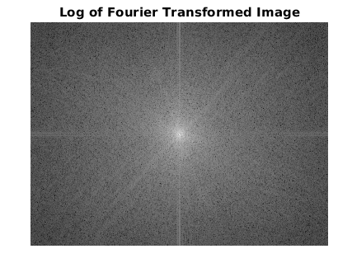

**Analysis 5:** Applied Logarithmic Function to see the different patterns of image and also for manipulating the Fourier co-efficient in order to enhance the reconstructed image. The brighter region at center is depicting the low frequency component and as we go away from the origin the region gets darker depicting the high frequency components and as a result brightness reduces.

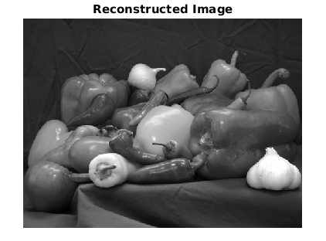

**Analysis 6:** Applied inverse functions in order to reconstruct the image.

**Failure:**

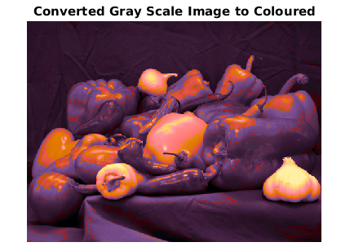

**Analysis 7:** The gray scale image is obtained in the last operation. We tried to convert this gray scale image into rgb form i.e. coloured image. There is no inbuilt function in MATLAB for doing operation gray2rgb so in MATLAB help we found code of such functions which we applied to it but we were not able to get the proper output as it is not MATLAB in-built function. As a result we obtained the above distorted image.

**Applications:**

* We can improve the quality of low-quality image.
* We can also do character recognition using FFT.
* By filtering out low frequency components, edges of the image can be detected.

**Conclusion:**

From this we did the Fourier transform analysis of the image. By manipulating the Fourier co-efficient of the original image it can be enhanced. There are very low frequency components depicting the brighter region as it do not carry much information while the higher frequency components depict the darker region as they have all the frequencies present containing high information. As the high frequency components increases the brighter region reduces. The failure faced is while converting Gray Scale Image into the RGB form.